Jay Balunan and Ma. Nelle Yap

University of san carlos

 City Gates

Android Mobile Application User Guide

Table of Contents

Getting Started 2

City Gates Christian Center 3

# Getting Started

Welcome to City Gates!

This is the official Android mobile application of the City Gates Christian Center.

We’ll discuss the features and guidelines on how to use the app in the next chapters.

The Developers

# City Gates Christian Center

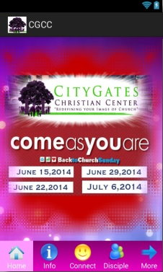

Gates Christian Center’s (CGCC) mission is to spread the Word of God and give hope to the broken. With the advancement of technology and the emergence of smartphones, the center came up to the idea of introducing an application that would reach out to more people.

City Gates is a mobile application for Android which provides information about the church activities.

